Proposal for ASFEE conference

Title: Production Risk and Input Use: Impact of Subsidies and Crop Insurance

Authors: Douadia Bougherara and Céline Nauges

Extended abstract:

Background and motivation: We study the impact of subsidies and crop insurance on the use of two types of inputs: risk decreasing and risk increasing. This research question is not new in agricultural economics. However, although theoretical predictions are established, the empirical evidence is not clear-cut. We argue that advances in experimental economics can give new insights on that issue. Our experimental approach allows dealing with three severe issues that face agricultural economists when using production data. First, the separate identification of risk preferences and technologies is possible in the lab since the experimenter controls for the parameters of the production function. Second, we overcome simultaneity issues such as the simultaneous choice of input use and crop insurance using a careful design of treatments in the lab. Third, we escape the selection bias issue by imposing mandatory insurance in some treatments as compared to others without insurance.

Experimental design: We consider a between and within subject design. Subjects play either a risk decreasing input session or a risk increasing input session. In each session, subjects first play a Holt and Laury lottery game for risk preference elicitation. Then, they play a series of production choices in a risk production context. Subjects have to choose the level of input X to produced output Z. The production function has two components such as risk increasing (resp. decreasing) input X increases mean production but also increases (resp. decreases) the variance of the output.

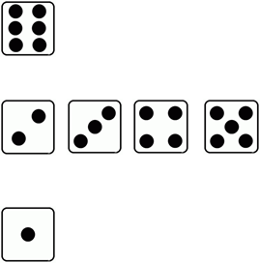
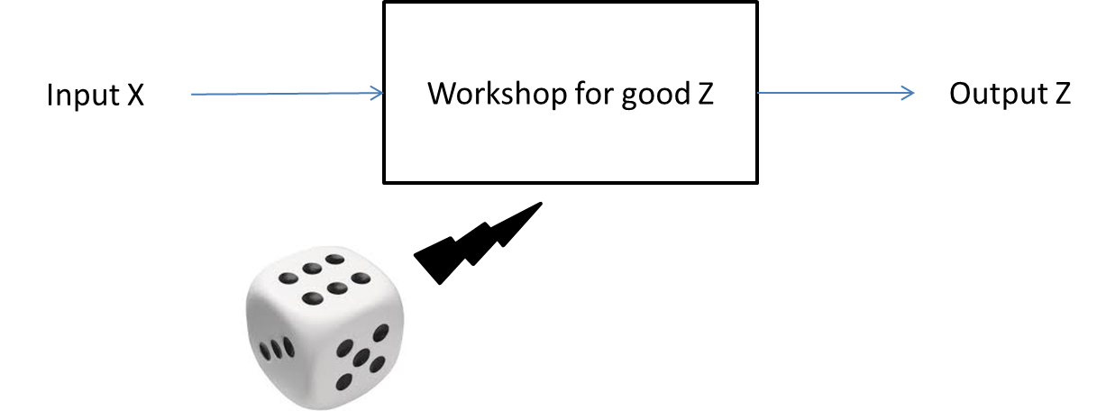
0 average
1 if favorable conditions

The random part of production depends on the level of input X but also on the result of a dice: favorable outcome if 6, unfavorable outcome if 1, no random part otherwise.

The timing is as follows:

We carry out 8 sessions where subjects choose the level of risk decreasing or risk increasing input to maximize profits under three types of treatments: benchmark, subsidy and actuarially fair crop insurance.

First results: First results show that (i) risk averse subjects use more risk decreasing input than risk increasing input, (ii) that the subsidy has a positive impact on the use of both types of inputs, and (ii) that crop insurance appears to be a complement to the use of risk decreasing input and a substitute to the use of risk increasing input.

Corresponding author ; Affiliation: INRA, UMR1135 LAMETA, F-34000 Montpellier; Address: UMR LAMETA, INRA SUPAGRO, 2, place Viala, 34 060 Montpellier Cedex 2; Phone: 0033 (0)4 99 61 24 08 ; E-mail: douadia.bougherara@inra.fr;
Affiliation: Toulouse School of Economics, INRA, Toulouse; Address: Toulouse School of Economics, Manufacture des Tabacs, 21 Allée de Brienne, 31015 Toulouse Cedex 6; Phone : 0033 (0)5 61 63 57 84; E-mail: celine.nauges@tse-fr.eu;

